**Component group issue fix**

**Problem statement:** Component group/component is not getting displayed in the design mode of the page.

**Solution:** Make sure the component is having dialog or cq:dialog created for the component.

If not, at least have cq:editConfig node of type “cq:EditConfig” inside the component. So that the component or the component group will get displayed in design mode.

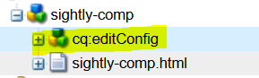

Search for the component group name after following the above instructions. It should list down your component group as shown below.

